|  |  |
| --- | --- |
| **Name** | **Esraa Salah Saad sharah** |
| **B. N** | **171** |
| **Topic** | **Programming laguages** |
| **Github link** |  |

**"Programming Languages" :_A computer programmer who uses it to develop scripts or other sets of instructions for computers to implement. Many languages ​​share similarities, but each has its own composition. Once the programmer learns the rules of languages ​​and structure, they write the source code in a text editor or IDE. After that, the programmer often compiles the code into the machine language that the computer can understand. Scripting languages, which do not require a translator, use a translator to execute the script.In addition, they are vocabulary and a set of grammatical rules to guide the computer or computer to perform specific tasks. The term programming language usually refers to high-level languages, such as BASIC C, C ++, COBOL, Java, FORTRAN, Ada and Pascal.**

**"Application of Programming languages_:"**

**Programming languages ​​use certain types of phrases, or instructions, to provide a functional framework for the program. A phrase in a program is a basic sentence that expresses a simple idea.**

**it is intended to give the computer basic instructions. The data specifies the types of data allowed, how to process the data, and the methods of working procedures and functions**

**Some programming languages ​​are written to address a specific type of computing problem or for use on a specific type of computer system.**

**Screenshot_:**

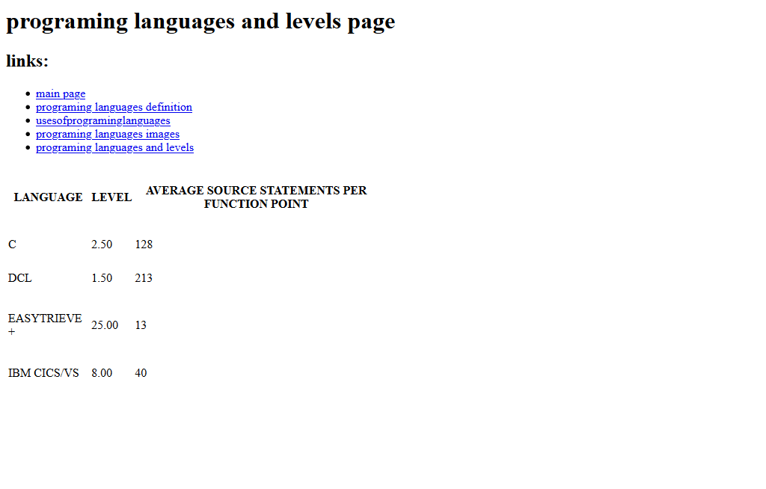

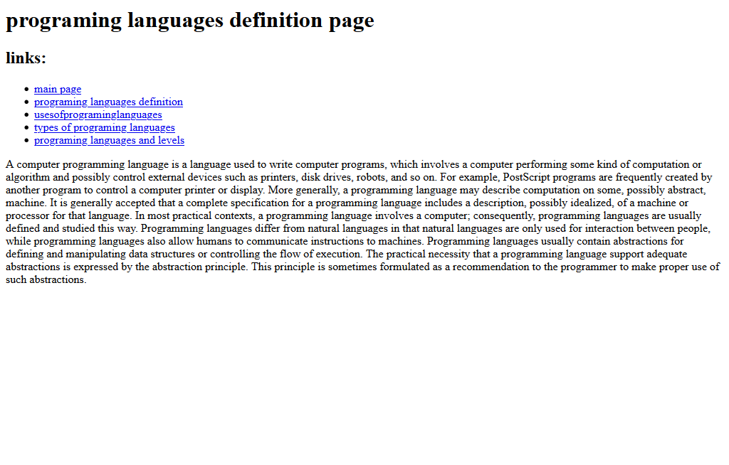

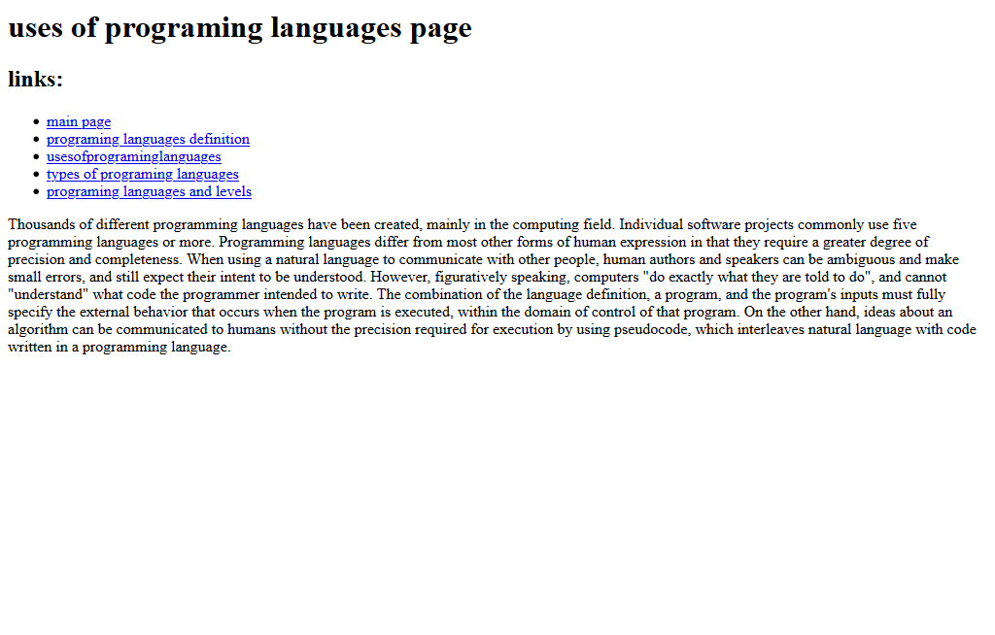

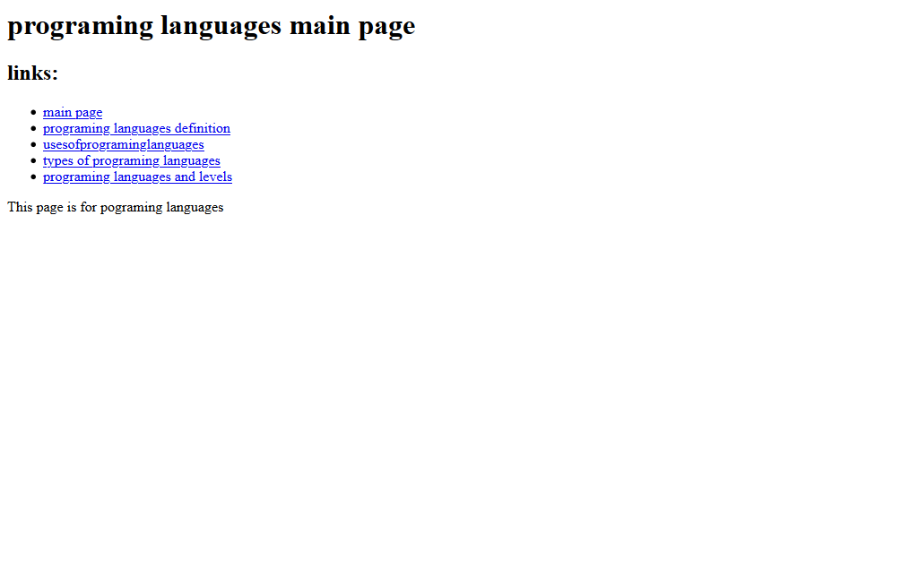

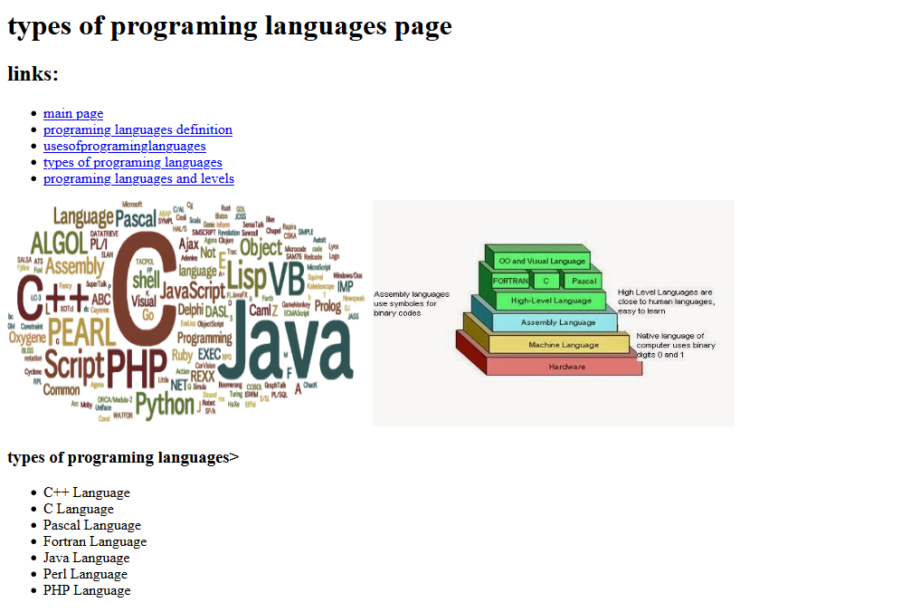

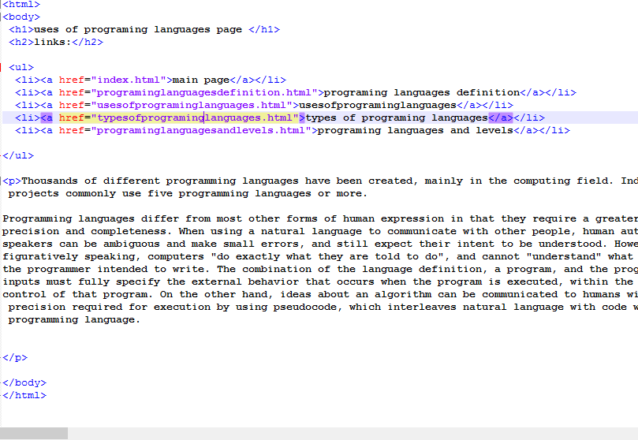Codes:-

